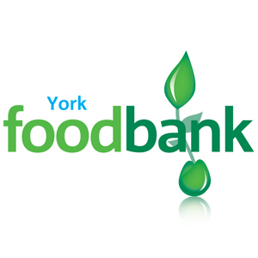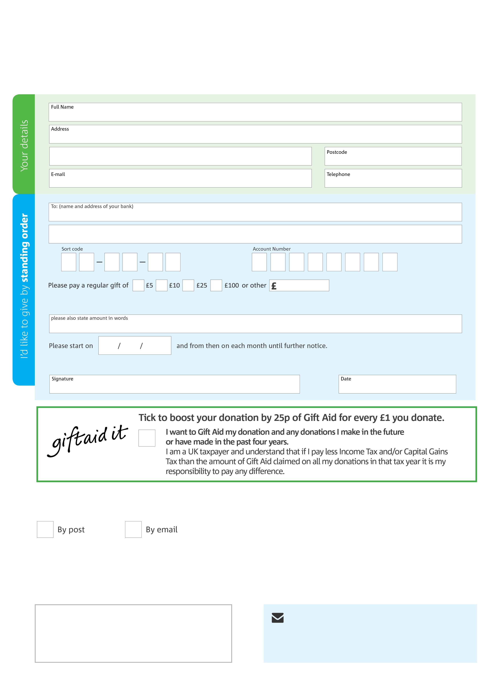­

**York Foodbank’s bank details:**

Sort code: 089299

Account number: 6567199500

**Please send your completed form to**

York Foodbank

Gateway Centre

Front Street

Acomb

York

YO243BZ

**Data protection**

York Foodbank is committed to protecting your privacy and will process your personal data in accordance with the Data Protection Act 1998. York Foodbank collects information to keep in touch with you and supply you with information relating to our work. York Foodbank will never sell or pass your details to anyone who isn’t directly working on our behalf.

**We would love to keep in touch with you so we can update you on our work. You can change your preferences any time by contacting us on 07871610894 or emailing us at info@york.foodbank.org.uk**

**Please tick here if you would be happy to receive communications from us:**

This cancels any previous standing order instructions to York Foodbank

To York Foodbank each month,

york.foodbank.org.uk

Reg. Charity No: 1154149 | Reg. in England & Wales